**Assignment 1 : Home Automation (Motion Capture – Security)**

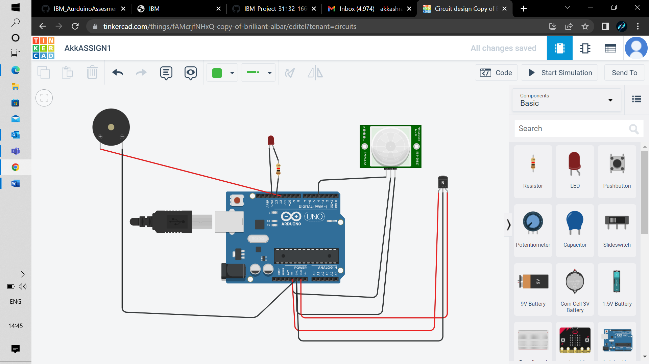

void setup()

{

Serial.begin(9600);

pinMode(4,INPUT);

pinMode(13,OUTPUT);

pinMode(12,OUTPUT);

}

void loop()

{

double p = digitalRead(4);

Serial.println(p);

digitalWrite(13,LOW);

double a=analogRead(A0);

double t=(((a/1024)*5)-0.5)*100;

Serial.print("TEMP value:");

Serial.println(t);

delay(1000);

if(p)

{

Serial.println("Motion detected!!!");

digitalWrite(13,HIGH);

digitalWrite(12,HIGH);

}

delay(1000);

}